**Aryaman Mishra**

**19BCE1027**

**VPN Configuration**

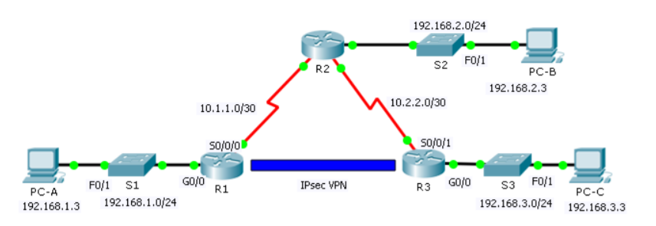

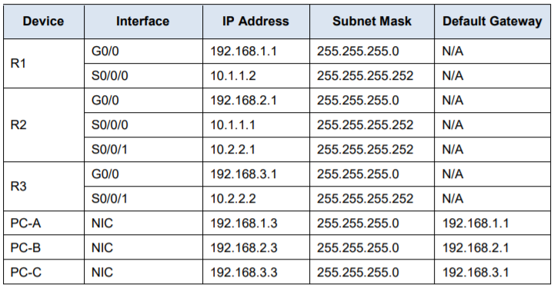

1. Starting configurations for R1, ISP, and R3. Paste to global config mode :

hostname R1

interface g0/1

ip address 192.168.1.1 255.255.255.0

no shut

interface g0/0

ip address 209.165.100.1 255.255.255.0

no shut

exit

ip route 0.0.0.0 0.0.0.0 209.165.100.2

hostname ISP

interface g0/1

ip address 209.165.200.2 255.255.255.0

no shut

interface g0/0

ip address 209.165.100.2 255.255.255.0

no shut

exit

hostname R3

interface g0/1

ip address 192.168.3.1 255.255.255.0

no shut

interface g0/0

ip address 209.165.200.1 255.255.255.0

no shut

exit

ip route 0.0.0.0 0.0.0.0 209.165.200.2

2. Make sure routers have the security license enabled:

show version

license boot module c1900 technology-package securityk9

copy run start

reload

3. Configure IPsec on the routers at each end of the tunnel (R1 and R3)

!R1

crypto isakmp policy 10

encryption aes 256

authentication pre-share

group 5

!

crypto isakmp key secretkey address 209.165.200.1

!

crypto ipsec transform-set R1-R3 esp-aes 256 esp-sha-hmac

!

crypto map IPSEC-MAP 10 ipsec-isakmp

set peer 209.165.200.1

set pfs group5

set security-association lifetime seconds 86400

set transform-set R1-R3

match address 100

!

interface GigabitEthernet0/0

crypto map IPSEC-MAP

!

access-list 100 permit ip 192.168.1.0 0.0.0.255 192.168.3.0 0.0.0.255

!R3

crypto isakmp policy 10

encryption aes 256

authentication pre-share

group 5

!

crypto isakmp key secretkey address 209.165.100.1

!

crypto ipsec transform-set R3-R1 esp-aes 256 esp-sha-hmac

!

crypto map IPSEC-MAP 10 ipsec-isakmp

set peer 209.165.100.1

set pfs group5

set security-association lifetime seconds 86400

set transform-set R3-R1

match address 100

!

interface GigabitEthernet0/0

crypto map IPSEC-MAP

!

R3

access-list 100 permit ip 192.168.3.0 0.0.0.255 192.168.1.0 0.0.0.255

R1

access-list 100 permit ip 192.168.1.0 0.0.0.255 192.168.3.0 0.0.0.255

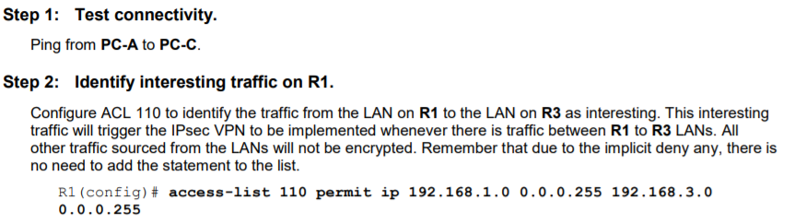

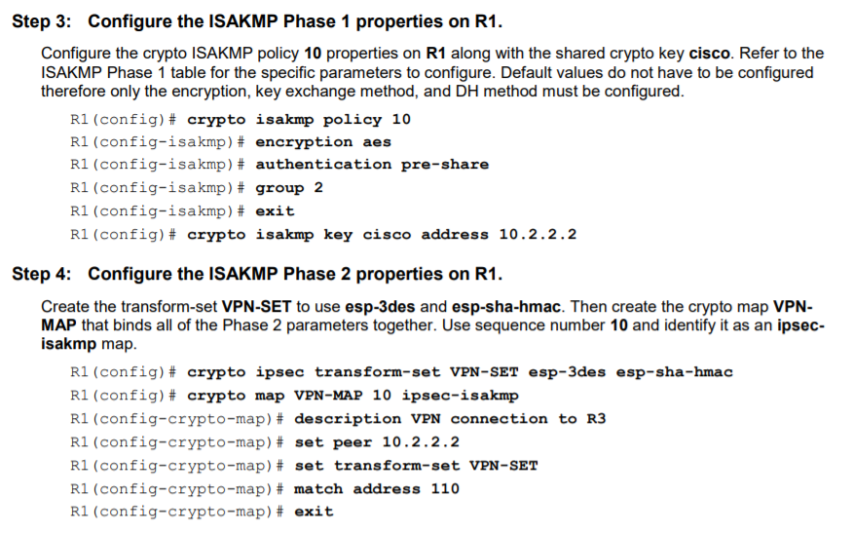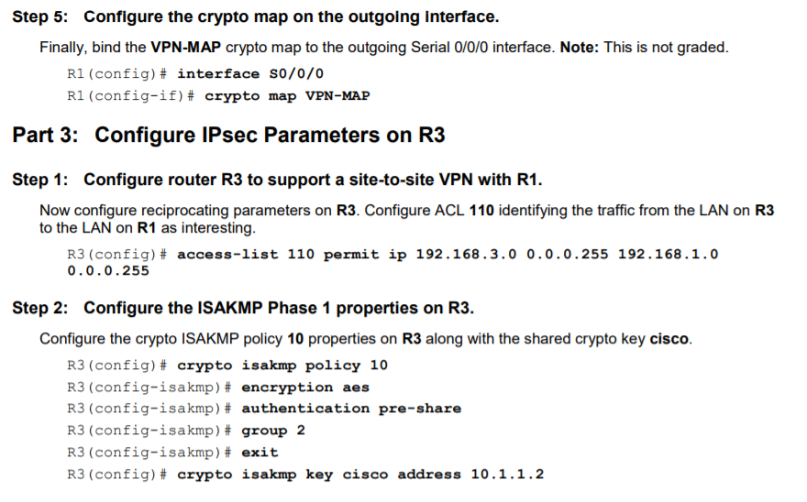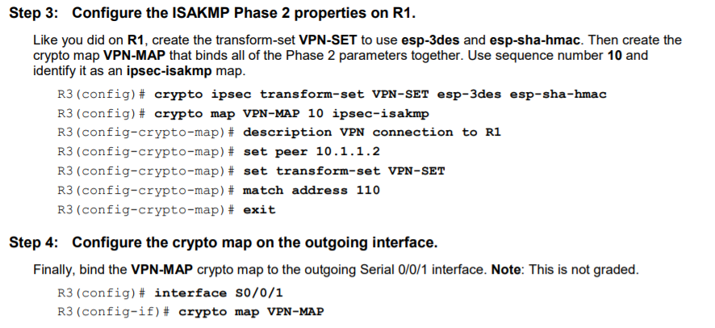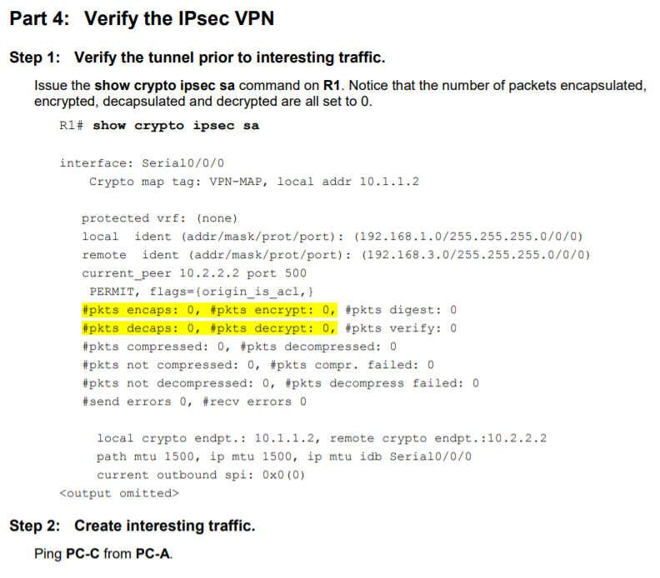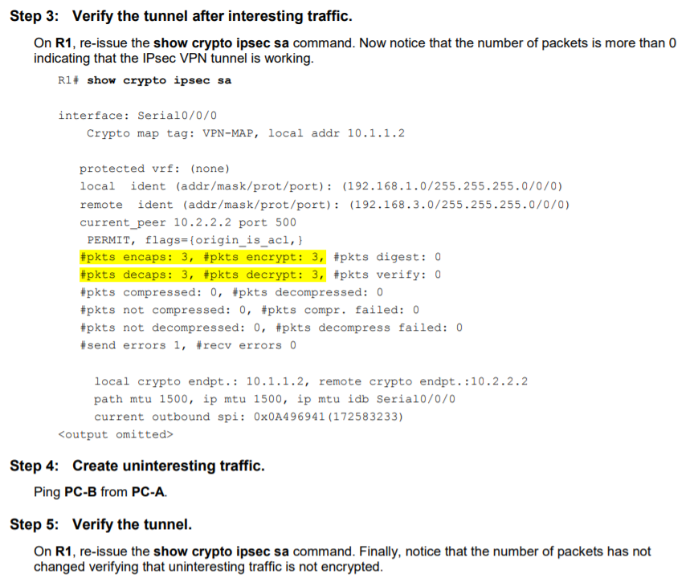

Output on next Page:

